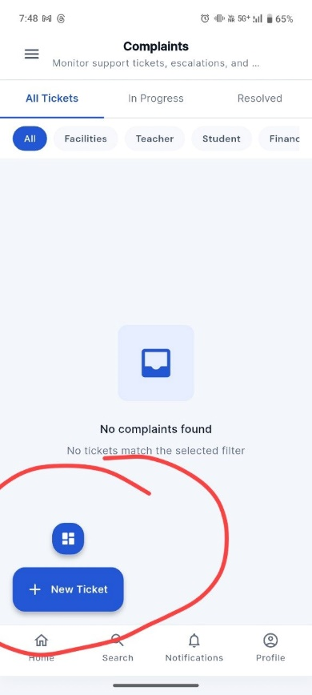
1.Both are looking confusing place it in proper place
Prompt: Use this high-level UI/UX prompt for fixing the layout professionally:

UI/UX Fix Prompt
Redesign the “Complaints” screen using modern high-level app design principles similar to Google, Notion, and Slack mobile apps.
Current issue:
- Floating action button and “New Ticket” button are placed too close together causing visual confusion.
- CTA hierarchy is unclear.
- Screen feels unbalanced and cluttered at the bottom-left area.
Required Fixes:
- Keep only ONE primary action button.
- Replace current layout with:
  - A single Floating Action Button (FAB) fixed at bottom-right corner.
  - Use “+” icon only OR “New Ticket” extended FAB, not both separately.
- Follow Material Design 3 spacing standards:
  - 16dp margin from edges
  - Proper elevation/shadow
  - Rounded corners
- Empty state should be centered vertically with:
  - Icon
  - “No complaints found”
  - Supporting text
- Bottom navigation must remain visually separated from FAB.
- Improve visual hierarchy:
  - Tabs aligned properly
  - Filter chips scrollable horizontally
  - Consistent padding throughout screen
- Use enterprise-grade clean design:
  - Minimal clutter
  - Professional spacing
  - Modern typography
  - Better balance between components
- FAB should never overlap navigation icons or content.
- Add subtle animations and ripple effects for interactions.
- Overall feel should match premium productivity apps.
Expected Result:
A clean, professional, intuitive complaint management screen with proper CTA placement, balanced spacing, and modern mobile UX standards.
2.Texts are too light imvisible
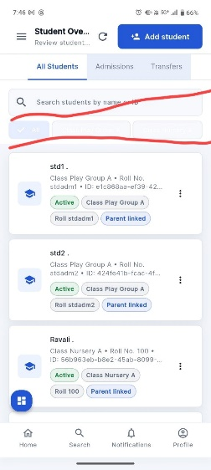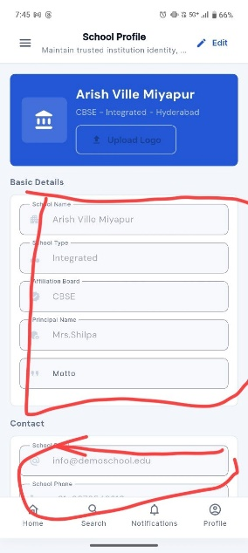
Prompt:
The issue I understood from the marked areas:

Screen 1 — Student List Page
- There is too much empty/unbalanced spacing between:
  - Search bar
  - Filter chips/tabs
  - Student cards
- The layout feels stretched vertically and wastes screen space.
- Cards are starting too low, reducing visible content.
- UI alignment and spacing are inconsistent with modern apps.

Screen 2 — School Profile Page
- Form fields are:
  - Too tall
  - Excessively spaced
  - Poorly aligned
- Large unused whitespace inside the form section.
- Bottom section is too close to bottom navigation.
- Overall form density is low, making the screen feel outdated and inefficient.

Professional UI/UX Fix Prompt
Use this prompt:

UI Spacing & Layout Optimization Prompt
Redesign these screens using modern enterprise mobile app UX standards similar to Google Workspace, Notion, and Microsoft apps.

Issues Identified
- Excessive vertical whitespace between components.
- Poor spacing hierarchy causing inefficient use of screen space.
- Form fields and cards are oversized.
- Content density is low, making screens feel stretched and outdated.
- Layout lacks proper visual rhythm and alignment.

Required Improvements

General Layout
- Reduce unnecessary vertical gaps between sections.
- Apply consistent 8dp / 12dp / 16dp spacing system.
- Maintain proper alignment grid throughout the screen.
- Optimize content density without making UI crowded.

Student List Screen
- Reduce gap between:
  - Search bar
  - Filter tabs/chips
  - Student cards
- Bring student cards higher on screen.
- Make filter chips compact and horizontally scrollable.
- Reduce card padding slightly for better information visibility.
- Ensure at least 2–3 cards are visible without scrolling.
- Keep FAB floating properly above bottom navigation.

School Profile Screen
- Reduce form field height.
- Minimize vertical spacing between input fields.
- Group related fields visually.
- Add balanced padding around form container.
- Prevent fields from touching bottom navigation area.
- Improve readability with cleaner typography hierarchy.
- Use compact modern form styling like Material Design 3.

Visual Design Standards
- Modern clean enterprise UI
- Proper visual hierarchy
- Balanced whitespace
- Compact yet readable layout
- Consistent rounded corners
- Soft shadows/elevation where needed
- Professional alignment and spacing
3. texts are imvisible
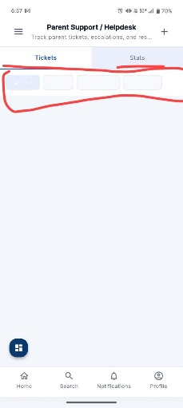
The issue I understood from the marked area:
- The filter chips/tabs section is breaking layout alignment.
- Chips look:
  - Too tall
  - Too widely spaced
  - Poorly padded
  - Visually disconnected from the tabs above
- There is excessive empty whitespace below the filters.
- The section feels unfinished and not professionally structured.
- Overall spacing hierarchy between:
  - Top app bar
  - Tabs
  - Filter chips
  - Content area
is inconsistent.
The UI currently looks stretched instead of compact and production-ready.

Professional Fix Prompt

Filter Chips & Top Section Layout Optimization Prompt
Redesign the top section of this mobile screen using modern high-level app UX standards similar to Google Workspace, Slack, and Notion mobile apps.

Issues Identified
- Filter chips are oversized and poorly aligned.
- Excessive spacing between tabs, chips, and content area.
- Weak visual hierarchy in top section.
- Empty whitespace makes the screen feel unfinished.
- Components lack proper grouping and compactness.

Required Improvements

Tabs Section
- Reduce vertical height of tabs.
- Use clean Material Design 3 style indicators.
- Improve active/inactive tab contrast.
- Keep tabs visually connected to content below.

Filter Chips
- Reduce chip height and padding.
- Use compact pill-style chips.
- Maintain consistent horizontal spacing.
- Ensure chips align properly in one clean row.
- Make chips horizontally scrollable if needed.
- Improve selected chip visibility with subtle background color.
- Add proper left/right margins (16dp).

Layout Spacing
- Reduce large empty gaps between:
  - App bar
  - Tabs
  - Chips
  - Main content
- Follow consistent spacing system:
  - 8dp internal spacing
  - 12dp between related components
  - 16dp screen margins

Content Area
- Content/cards should begin immediately after filters with balanced spacing.
- Avoid large blank sections that waste screen space.

Visual Standards
- Enterprise-grade modern UI
- Compact and efficient layout
- Balanced whitespace
- Clean alignment grid
- Smooth visual hierarchy
- Production-ready appearance

Expected Result
A polished, compact, and professional top section where tabs and filter chips feel visually connected, properly aligned, and efficiently spaced like premium modern mobile applications.
4. looking to confused showing all buttons repeatedly
Prompt: The issues I understood from the marked areas:

1. Top App Bar Issue
- “Save as PDF” section is taking excessive horizontal space.
- Header layout feels unbalanced and outdated.
- Controls (paper size, dropdowns) are poorly aligned.
- Toolbar lacks clean spacing hierarchy.

2. Floating Action Button Issue
- Blue FAB/button is floating awkwardly.
- It feels disconnected from the layout.
- Positioning overlaps visual focus area.
- CTA placement is not following modern PDF preview UX patterns.

3. Card Preview Issue
- PDF preview card is too small and poorly centered.
- Large empty whitespace around the preview.
- Content scaling/alignment feels broken.
- The preview does not use available screen space efficiently.

4. Overall Layout Problem
- Screen lacks structure and professional spacing.
- Visual hierarchy is weak.
- UI looks stretched and unoptimized instead of premium.

Professional UI/UX Fix Prompt

PDF Preview Screen Modernization Prompt
Redesign this PDF preview/export screen using premium mobile UX standards similar to Google Drive PDF preview, Adobe Acrobat mobile, and Microsoft Office apps.

Issues Identified
- Top toolbar is oversized and poorly aligned.
- Floating action button placement feels awkward and disconnected.
- PDF preview card is too small and surrounded by excessive whitespace.
- Layout lacks proper visual hierarchy and balance.
- Screen does not utilize available space efficiently.

Required Improvements

Top App Bar
- Create a compact modern toolbar.
- Reduce toolbar height.
- Align:
  - Title
  - Dropdowns
  - Actions
properly in one structured row.
- Use cleaner typography hierarchy.
- Reduce excessive padding around controls.
- Replace outdated dropdown styling with modern compact selectors.

PDF Preview Area
- Increase PDF preview size significantly.
- Center preview properly both horizontally and vertically.
- Reduce unnecessary whitespace around document.
- Make preview responsive and proportional.
- Add subtle shadow/elevation to preview card.
- Maintain proper margins from screen edges.

Floating Action Button
- Reposition FAB to bottom-right with proper safe margin.
- Ensure FAB does not overlap important content.
- Use Material Design 3 floating action behavior.
- Add proper elevation and ripple animation.
- Make FAB visually connected to the action flow.

Layout & Spacing
- Follow consistent spacing system:
  - 8dp internal spacing
  - 12dp section spacing
  - 16dp outer margins
- Improve component grouping and alignment.
- Remove large empty unused areas.

Visual Design Standards
- Clean enterprise-grade appearance
- Compact professional layout
- Balanced whitespace
- Modern PDF viewer experience
- Production-ready mobile UI
- Smooth visual hierarchy

Expected Result
A polished and modern PDF preview screen with:
- Compact professional toolbar
- Properly scaled document preview
- Better space utilization
- Correct FAB placement
- Clean alignment and spacing
- Premium user experience similar to top productivity apps
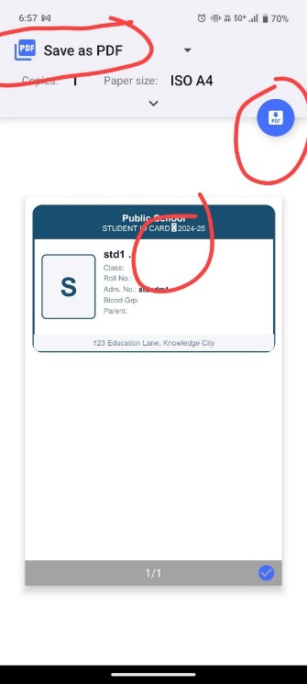
5. Text lookingX light and also buttons are collided with text

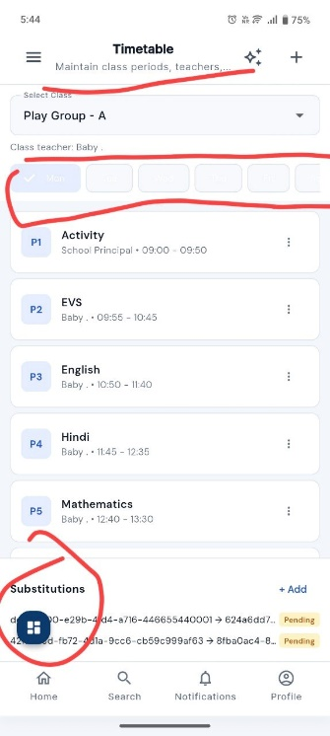
The issues I understood from the marked areas:

1. Top Header Spacing Issue
- The subtitle (“Maintain classes, teachers…”) is too close to the app bar and tabs.
- Header area lacks proper spacing hierarchy.
- Top section feels compressed and visually cluttered.

2. Day/Date Selector Issue
- The horizontal date/day chips are:
  - Too small
  - Poorly aligned
  - Inconsistent in spacing
  - Difficult to read/interact with
- Large unused whitespace around the selector.
- Component does not look production-ready.

3. Floating Action Button Issue
- FAB is placed in the bottom-left corner where it conflicts with:
  - Bottom navigation
  - Substitutions section
- The FAB visually interrupts content flow.
- Placement feels random instead of intentional.

4. Overall Layout Problem
- The screen lacks proper spacing rhythm.
- UI hierarchy between:
  - Header
  - Filters
  - Timetable cards
  - FAB
is inconsistent.
- Layout looks crowded in some places and empty in others.

Professional UI/UX Fix Prompt

Timetable Screen Layout & FAB Optimization Prompt
Redesign the timetable screen using modern enterprise mobile UX standards similar to Google Calendar, Notion, and Microsoft Teams mobile apps.

Issues Identified
- Header spacing is cramped and visually inconsistent.
- Date/day selector chips are too small and poorly aligned.
- Floating action button conflicts with content and bottom navigation.
- Layout hierarchy and spacing rhythm are inconsistent.
- Screen lacks premium production-ready polish.

Required Improvements

Header Section
- Add proper spacing between:
  - App bar
  - Subtitle
  - Filters
- Improve typography hierarchy:
  - Clear title prominence
  - Softer subtitle styling
- Reduce visual clutter in top section.

Day/Date Selector
- Redesign chips into compact modern pill-style selectors.
- Increase readability and touch area.
- Use consistent spacing between chips.
- Make selector horizontally scrollable.
- Clearly highlight selected day/date.
- Add balanced left/right padding (16dp).

Timetable Cards
- Maintain consistent spacing between subject cards.
- Reduce unnecessary internal padding.
- Improve alignment of:
  - Period labels
  - Subject names
  - Timing text
- Keep cards visually compact but readable.

Floating Action Button
- Move FAB to bottom-right corner.
- Ensure FAB stays above bottom navigation with safe margin.
- Prevent overlap with substitutions section.
- Use Material Design 3 FAB styling:
  - Proper elevation
  - Ripple animation
  - Balanced sizing

Bottom Section
- Give “Substitutions” section proper spacing from FAB.
- Improve section hierarchy and alignment.
- Avoid crowded bottom layout.

Layout & Spacing Standards
- Follow consistent spacing system:
  - 8dp internal spacing
  - 12dp section spacing
  - 16dp outer margins
- Ensure balanced whitespace throughout screen.

Visual Standards
- Enterprise-grade modern UI
- Clean professional appearance
- Compact but readable layout
- Smooth visual hierarchy
- Production-ready mobile experience

Expected Result
A polished timetable screen with:
- Better header spacing
- Modern date selector
- Proper FAB positioning
- Balanced layout hierarchy
- Improved readability
- Premium productivity app appearance.
6. Texts are out of box and generate is hidden and down text is collided with buttons

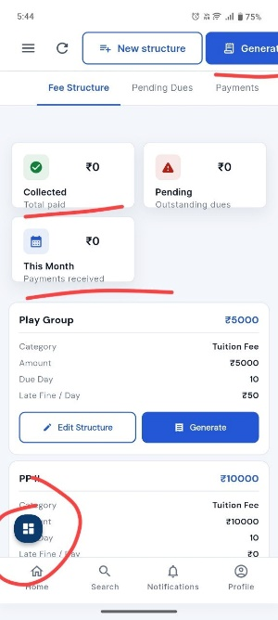
The issues I understood from the marked areas:

1. Large Unnecessary Gap Between Sections
- There is excessive whitespace between:
  - Summary statistic cards
  - Fee structure detail cards
- The layout feels disconnected and stretched vertically.
- Screen space is not utilized efficiently.

2. Floating Action Button Placement Issue
- FAB is placed in the bottom-left corner.
- It overlaps visually with:
  - Content cards
  - Bottom navigation area
- Placement breaks modern mobile UX standards.
- FAB feels intrusive and distracting.

3. Poor Visual Flow
- Sections do not transition smoothly.
- Information hierarchy feels broken due to uneven spacing.
- Important content is pushed too far apart.

4. Content Density Problem
- Too little information is visible on screen at once.
- User needs unnecessary scrolling.
- Layout lacks compact enterprise-grade organization.

Professional UI/UX Fix Prompt

Fee Structure Screen Spacing & FAB Optimization Prompt
Redesign this fee structure screen using modern high-level mobile UX standards similar to Google Workspace, Stripe Dashboard, and Microsoft enterprise apps.

Issues Identified
- Excessive whitespace between summary cards and fee detail sections.
- Floating action button overlaps content and bottom navigation.
- Poor spacing rhythm breaks visual hierarchy.
- Layout feels stretched and inefficient.
- Screen lacks compact production-ready organization.

Required Improvements

Section Spacing Optimization
- Reduce vertical gap between:
  - Summary cards
  - Fee detail cards
- Create tighter visual grouping between related sections.
- Maintain balanced spacing without making UI crowded.

Summary Cards
- Keep cards aligned in a clean responsive grid.
- Use consistent card heights and spacing.
- Improve compactness while preserving readability.
- Reduce unnecessary padding inside cards.

Fee Detail Cards
- Bring cards closer to summary section.
- Improve internal alignment of:
  - Labels
  - Values
  - Buttons
- Reduce excessive top and bottom margins.
- Ensure better information density.

Floating Action Button
- Move FAB to bottom-right corner.
- Maintain:
  - 16dp safe margin from edges
  - Proper spacing above bottom navigation
- Ensure FAB never overlaps cards or navigation icons.
- Use Material Design 3 FAB styling:
  - Proper elevation
  - Circular clean design
  - Ripple animation

Layout & Hierarchy
- Improve visual flow from top to bottom.
- Use consistent spacing system:
  - 8dp internal spacing
  - 12dp component spacing
  - 16dp outer margins
- Remove large blank unused areas.
- Create smooth content continuity.

Visual Standards
- Enterprise-grade clean UI
- Compact professional layout
- Balanced whitespace
- Modern dashboard appearance
- Production-ready mobile experience
- Better content visibility

Expected Result
A polished fee management screen with:
- Better space utilization
- Compact and readable layout
- Proper FAB placement
- Strong visual hierarchy
- Smoother section transitions
- Premium enterprise mobile app appearance.
7. Text is too light and text under students can kept as scroll
The issues I understood from the marked area:

1. Filter Chips Are Visually Broken
- Filter chips/buttons look:
  - Disabled
  - Washed out
  - Low contrast
  - Hard to read
- Selected and unselected states are unclear.

2. Poor Spacing & Alignment
- Chips are too close to the search bar.
- Uneven internal padding makes them look compressed.
- Horizontal spacing between chips is inconsistent.

3. Weak Visual Hierarchy
- Filters do not stand out as interactive elements.
- The filter section blends into the background.
- UI lacks proper structure between:
  - Search bar
  - Filters
  - Student cards

4. Component Sizing Problem
- Chips are too large vertically but still feel cramped internally.
- Layout wastes horizontal space.
- Text alignment inside chips is poor.

5. Overall UX Issue
- Filter section looks unfinished and not production-ready.
- Does not match modern enterprise mobile app standards.

Professional UI/UX Fix Prompt

Student Filter Chips & Search Section Optimization Prompt
Redesign the student filter/search section using modern enterprise mobile UX standards similar to Google Workspace, Slack, and Microsoft Teams apps.

Issues Identified
- Filter chips have poor visibility and weak interaction states.
- Spacing between search bar and chips is inconsistent.
- Chips look disabled and visually outdated.
- Layout hierarchy is weak and unbalanced.
- Filter section lacks production-ready polish.

Required Improvements

Search Bar
- Reduce unnecessary spacing below search bar.
- Use compact modern search field styling.
- Add proper internal padding and alignment.
- Ensure search field visually separates from filters.

Filter Chips
- Redesign chips into modern pill-style selectors.
- Improve selected/unselected visual states:
  - Selected chip → filled background with high contrast text
  - Unselected chip → outlined or subtle background
- Increase readability and touch feedback.
- Use consistent horizontal spacing between chips.
- Make chips compact and properly padded.
- Ensure text is vertically centered.
- Make chips horizontally scrollable if needed.

Layout & Spacing
- Follow consistent spacing system:
  - 8dp internal spacing
  - 12dp between related components
  - 16dp screen margins
- Reduce large empty gaps.
- Keep filters visually connected to student list.

Visual Hierarchy
- Clearly separate:
  - Search section
  - Filter controls
  - Student cards
- Improve interaction visibility.
- Make filters feel active and modern.

Student Cards
- Maintain consistent spacing from filters.
- Improve visual flow into card list.
- Keep information density balanced and readable.

Visual Standards
- Modern enterprise-grade UI
- Compact professional layout
- Balanced whitespace
- Material Design 3 styling
- Clean alignment grid
- Production-ready mobile experience

Expected Result
A polished and modern student management screen with:
- Professional filter chip design
- Better search/filter hierarchy
- Improved spacing and readability
- Stronger interaction visibility
- Compact enterprise-style layout
- Premium production-ready appearance.

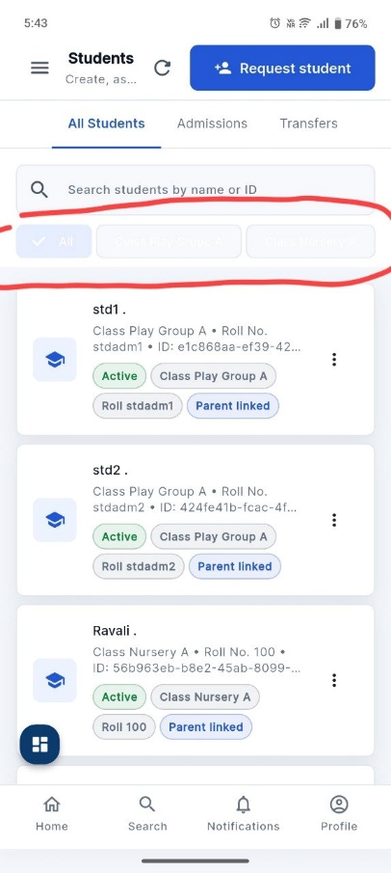
8. page looks empty
Prompt: The issue I understood from the marked area:

1. Excessive Empty Whitespace
- There is a very large unused blank area in the lower half of the screen.
- The content is pushed too far upward, making the screen feel incomplete and unbalanced.

2. Poor Vertical Layout Distribution
- The profile form components occupy only a small portion of the screen.
- Remaining space is not utilized effectively.
- Layout lacks proper content flow and structure.

3. Weak Visual Balance
- Top section feels crowded while bottom section is completely empty.
- The screen does not maintain a balanced spacing rhythm.
- UI feels unfinished and not production-ready.

4. Missing Bottom Content Structure
Possible missing elements:
- Save/Update button
- Account settings
- Preferences section
- Logout option
- Activity info
- Security settings
Without these, the screen appears visually incomplete.

5. Overall UX Problem
- The page lacks modern enterprise mobile app density and organization.
- It does not follow professional profile/settings screen patterns used in high-level apps.

Professional UI/UX Fix Prompt

Profile Screen Layout & Space Optimization Prompt
Redesign the profile screen using modern enterprise mobile UX standards similar to Google Account, Microsoft Profile, and Notion mobile apps.

Issues Identified
- Excessive unused whitespace in lower screen area.
- Poor vertical content distribution.
- Layout feels incomplete and visually unbalanced.
- Missing structured bottom actions/settings.
- Screen lacks production-ready hierarchy and organization.

Required Improvements

Layout Structure
- Optimize vertical space utilization.
- Reduce unnecessary empty areas.
- Create smooth content flow from top to bottom.
- Maintain balanced spacing between all sections.

Profile Header Card
- Keep profile card compact but visually prominent.
- Improve spacing inside profile card:
  - Avatar
  - Username
  - Role
- Add subtle elevation/shadow.

Form Fields
- Reduce excessive field height.
- Use compact modern input styling.
- Maintain consistent spacing between fields.
- Improve alignment of:
  - Labels
  - Icons
  - Input text

Bottom Section Enhancement
Add structured actions such as:
- Save Changes button
- Account Settings
- Security Settings
- Change Password
- Logout option
OR
Use proper bottom spacing if no additional content exists.

CTA/Button Placement
- Add a primary action button near the bottom:
  - “Save Changes”
  - “Update Profile”
- Ensure button follows Material Design 3 standards.
- Maintain safe spacing above bottom gesture/navigation area.

Layout & Spacing Standards
- Use consistent spacing system:
  - 8dp internal spacing
  - 12dp component spacing
  - 16dp outer margins
- Ensure balanced whitespace instead of large empty gaps.

Visual Standards
- Modern enterprise-grade UI
- Compact professional layout
- Better information density
- Balanced visual hierarchy
- Clean alignment grid
- Production-ready mobile UX

Expected Result
A polished and modern profile screen with:
- Proper space utilization
- Balanced layout distribution
- Improved content hierarchy
- Structured bottom actions
- Better readability
- Premium enterprise mobile app appearance.

